THE USE OF THE AUTOMATED EXTERNAL DEFIBRILLATOR (AED)
WITHIN THE WORKPLACE

WHY IS AN AED REQUIRED WITHIN THE WORKPLACE? “Sudden cardiac arrest (SCA) is a leading cause of premature death, but with immediate treatment many lives can be saved. SCA occurs because the electrical rhythm that controls the heart is replaced by a chaotic disorganised electrical rhythm called ventricular fibrillation (VF). The quicker VF can be treated by defibrillation the greater the chance of successful resuscitation. Seconds count, and the ambulance service is unlikely to arrive quickly enough to resuscitate most victims. The automated external defibrillator (AED) has been described as the single most important development in the treatment of SCA. Under ideal circumstances, when used very soon after collapse (within two or three minutes), many can survive. The crucial determinant of survival is the interval between collapse and the use of the AED to deliver a shock. The strategy, therefore, is to have an AED installed at a place where it might be needed so that it can be accessed quickly by someone nearby, taken to the person who has collapsed, and used before the arrival of professional help” Resuscitation Council (UK) and British Heart Foundation December 2013

WHO CAN USE AN AED? “All healthcare professionals should consider the use of an AED to be an integral component of BLS. Untrained employees working in healthcare establishments should not be prevented from using an AED if they are confronted with a patient in SCA. The administration of a defibrillatory shock should not be delayed while waiting for a more highly trained person to arrive. The use of AEDs by people who were not health professionals was introduced in the UK as a government-led initiative (the “Defibrillators in Public Places Initiative”) in 1999. An AED can be used safely and effectively without previous training. Therefore, the use of an AED should not be restricted to trained rescuers. However, training should be encouraged to help improve the time to shock delivery and correct pad placement” Resuscitation Council (UK).

HOW DOES THE HEART WORK? The heart is a muscle that creates its own electrical impulses.
- The two top chambers (atria) collect blood and push it into the chambers below (ventricles).
- The “primary pacemaker” (sinoatrial node) at the top right-hand side of the heart fires an electrical impulse through the heart to make it contract, passing through the atria first.
- The electrical impulse then reaches the “secondary pacemaker” (atrioventricular node) which passes it along a bundle of cables between the two top chambers into the ventricles below, which contract from the bottom upwards, pumping the blood out of the heart.
- The heart’s electrical cells then “recharge” ready for the next wave of electricity.
WHAT CAN GO WRONG?
- If the primary pacemaker does not fire an impulse, the secondary pacemaker should fire one instead, which will hopefully still pump blood and keep the casualty alive.
- If the secondary pacemaker fails, an electrical cell in the bundle of cables should fire an impulse, so the heart does have electrical “back- ups” to protect it from stopping altogether.
- When a myocardial infarction (heart attack) occurs an area of the heart loses its blood supply and dies.
- The dying area becomes very unstable, often firing off its own electrical impulses
- These impulses interrupt the normal electrical activity causing the heart to miss a beat (an irregular pulse).
- If this happens when the cells are re-charging, the whole electrical system can become disrupted.
- Instead of beating in a co-ordinated rhythm, the heart’s electrical cells start firing independently of each other, producing a chaotic rhythm.

The term “heart attack” is often used to refer to SCA, but this is incorrect. A heart attack (or myocardial infarction) occurs when an artery supplying the heart becomes blocked. This usually causes chest pain and leads to damage to some of the muscle of the heart. It may cause SCA, particularly in the early stages, but this is by no means inevitable. It is important, therefore, to send for the emergency services as soon as a heart attack is suspected so that treatment can be given to reduce damage and the risk of SCA. It is at this time that the AED should be made available in case the casualty does go on to suffer a cardiac arrest, in which case the first shock can be given without delay and maximise the chance of survival.

HEART RYTHMS The AED will analyse the heart’s rhythm, which is likely to be in one of four, listed below:
Normal (normal sinus rhythm)
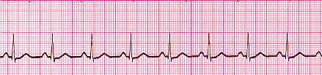

Ventricular fibrillation (VF)
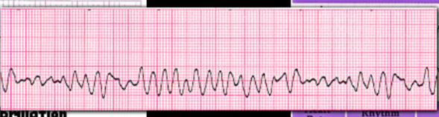

Ventricular tachycardia (VT)
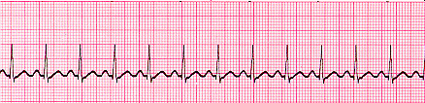

Asystole (no activity)
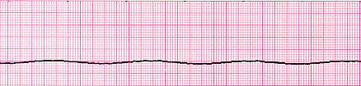

The normal rhythm and the asystolic rhythm are both “non-shockable” rhythms. The defibrillator will not shock a heart that is beating normally, neither can it shock the asystolic rhythm, as there is no electrical activity at all. This occurs after the heart has eventually run out of oxygen. This is commonly referred to as “flatline”.
This means that the AED will only deliver a shock if the heart is in a shockable rhythm, and contrary to what many believe, does not “jump-start” a heart that has finally stopped. The shock it delivers is designed to cause the heart’s electrical cells to re-charge, bringing the heart to a standstill, thus stopping the mis-fires. Once the heart has stopped, its own pacemaker should start up again, hopefully sending normal impulses once again. Maybe the best way of describing the process is as similar to “rebooting” a computer. The AED will continue to deliver a shock every two minutes for as long as the heart remains in this shockable rhythm , until it begins to beat normally again, or stops altogether.

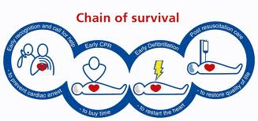
If a casualty suffers a cardiac arrest, there is a sequence of events that must happen in order for them to stand a chance of survival. This is known as the “Chain of Survival”.
WHAT IS THE SEQUENCE OF EVENTS?
- Early recognition and call for help. Help must be summoned immediately so that the other links in the chain of survival can happen. Remember, in the case of a heart attack most casualties look and feel ill for a while, so it is important to call for help if you think a person might have a cardiac arrest so that help can arrive before they collapse. Ideally, send someone else to call for the emergency services (EMS) and tell them to come back as soon as possible. If no-one is available then make the call yourself and tell them you are alone and if you are about to start CPR.
- Early CPR. The purpose of early CPR is to buy time for the casualty. Chest compressions are needed to push blood around the body and inflations are needed to deliver more oxygen. If there is access to oxygen and breathing apparatus, high-flow oxygen should be delivered via the Bag Valve Mask (BVM). Early CPR has been proven to more than double the chances of survival. Effective CPR with the use of oxygen increases the chance of successful defibrillation.
- Early defibrillation. Defibrillation is the only effective treatment for a casualty in SCA, and for every minute it takes to deliver the first shock the chance of survival reduces by as much as 10%. Therefore, the most important determinant to survival is the delay from collapse to delivery of the first shock. Remember – “only rarely are the EMS able to attend and provide defibrillation early enough, and the best way of ensuring prompt defibrillation is for someone nearby to use an AED to deliver the shock that can often save a life” (Resuscitation Council (UK).
- Early advanced care. Early advanced care from professional medical personnel is essential to stabilise the casualty and increase their chance of survival.

RESUSCITATION WITH THE USE OF AN AED
DANGER
- Make sure that the casualty, yourself and any bystanders are safe
CHECK FOR RESPONSE
- If there is no response from the casualty, shout for help immediately
AIRWAY
- Carefully open the airway by tilting the head and lifting the chin
BREATHING
- Keeping the airway open, look, listen and feel to see if the casualty is breathing. Take no more than 10 seconds to do this
IF THE CASUALTY IS BREATHING NORMALLY
- Place the casualty into the recovery position
- Send for EMS
- Deliver oxygen to casualty via non-rebreathing face mask if available

IF THE CASUALTY IS NOT BREATHING, NOT BREATHING NORMALLY, OR IF YOU ARE UNSURE
- If you are on your own, ring for EMS AND GET THE AED
- If you have help, start CPR immediately whilst the helper(s) ring for EMS and get the AED. If there is anyone else available send them for the oxygen and breathing apparatus if available
CONTINUE CPR USING RATIO OF 30 COMPRESSIONS TO 2 INFLATIONS UNTIL AED ARRIVES
AS SOON AS THE AED ARRIVES:
- If you are still on your own, immediately follow the instructions below
- If you have help, continue to deliver CPR, while the other person takes charge of the AED and follows the instructions below
- Switch on the AED immediately and follow the voice prompts
- Cut through clothing to expose the casualty’s bare chest
- You may need to towel dry or shave the casualty’s chest so that the pads stick properly. Only shave excessive hair where the pads are to be positioned and don’t delay defibrillation if a razor is not available
- To place the pads, peel one pad from the plastic backing and place it to the right of the sternum (breast bone) just below the casualty’s right clavicle (collar bone) as shown on the pad
- Peel the second pad from the backing and place on the lower chest wall on the left, just below the apex of the heart, as shown on the pad DO NOT REMOVE THE PADS TO REPOSITION THEM IF YOU HAVE PLACED THEM THE WRONG WAY ROUND – THE AED WILL STILL WORK
- The AED will now prompt you to STOP CPR AND STAND CLEAR. This is so that it can analyse the heart’s rhythm. YOU WILL NOT GET A SHOCK AT THIS STAGE – HOWEVER THE AED CANNOT SUCCESSFULLY DETERMINE THE RHYTHM IF THE CASUALTY IS MOVING DUE TO ON-GOING CPR. EVEN IF YOU STOP CPR BUT REMAIN IN CONTACT WITH THE CASUALTY THE AED MAY DETECT YOUR OWN HEART’S RHYTHM AND THIS WILL CAUSE A DELAY
IF A SHOCK IS ADVISED
- Ensure that nobody touches the casualty. The AED will now begin to charge, ready to deliver the shock
- Once the AED is fully charged it is ready to deliver the shock
- If the AED is FULLY AUTOMATIC it will count down and deliver the shock automatically
- If the AED is SEMI AUTOMATIC the “shock” button will begin to flash, and you will be told to press it. REMEMBER THAT IT IS IMPORTANT NOT TO TOUCH THE CASUALTY UNTIL THE SHOCK HAS BEEN DELIVERED
- The AED will now prompt you to resume CPR for 2 minutes before it needs to analyse the rhythm again
- Continue CPR, following the voice/visual prompts when delivered
- Minimise, as far as possible, interruptions to chest compressions

IF A SHOCK IS NOT ADVISED:
- Immediately resume CPR using the ratio of 30 compressions to 2 inflations
- Continue as directed every 2 minutes by the voice/visual prompts
CONTINUE TO FOLLOW THE AED PROMPTS UNTIL:
- Qualified help arrives and takes over OR
- The casualty shows signs of regaining consciousness, such as coughing, opening the eyes, speaking or moving purposefully AND starts to breath normally OR
- You become exhausted
ALWAYS LEAVE THE ELECTRODE PADS ON THE CASUALTY EVEN IF THEY APPEAR TO HAVE RECOVERED AS THEIR CONDITION MAY QUICKLY DETERIORATE

- The instructions above follow the latest Resuscitation Council (UK) guidelines published in October 2010. Some older AEDs (pre 2006) may use older guidelines. If you have an AED that you think may be pre 2006 check with your AED supplier as an update may be available. If your AED follows older guidelines it is still acceptable to use it (following the voice prompts) as defibrillation using older guidelines is better than no defibrillation at all.

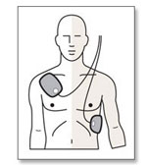
CORRECT PLACEMENT OF ELECTRODE PADS ON AN ADULT

RESCUE PACK It is advisable to carry the following with the AED:
- Scissors You will probably need to cut open clothing to expose the bare chest. It’s therefore advisable to have a strong pair that are capable of cutting through thick material, but will not cut the skin, such a “tough cut” safety scissors.
- Razor A good quality disposable razor will remove any excessive chest hair where the pads need to be applied, to ensure that they stick closely to the skin.
- Small towel/flannel It is common for a casualty suffering a heart attack to sweat profusely and the chest should be dried to ensure a secure adhesion of the pads.
It is also recommended that you also include the following:
- Spare AED pads If a pad gets torn, or fails to stick properly, having spare pads will save time.
- Paediatric pads Most machines require paediatric pads to be connected before using the AED on a child (1-8 years).
- Protective gloves Always wear protective gloves when dealing with a casualty.

AED SAFETY CONSIDERATIONS
- Jewellery Take care not to place pads over jewellery such as necklaces. This would conduct the electricity and burn the casualty. There is no need to remove piercings, but ensure that pads are not placed over them.
- Medication patches Some heart patients wear a glyceryl tri-nitrate (GTN) patch which may explode if electricity passes through it, so remove ALL visible medication patches as a precaution.
- Implanted devices Some heart patients may have a pacemaker or defibrillator implanted. These can usually be seen or felt just below the left collar bone, which is not normally in the way of the pads so care must be taken not to place pads over them.
- Supplemental oxygen There are no reports of fires caused by sparking where defibrillation was delivered using adhesive pads. If oxygen is being delivered via a face mask, remove the mask and place it at least one metre away before the shock is delivered. However, do not allow this to delay shock delivery.
- Defibrillation if the casualty is wet As long as there is no direct contact between the user and the casualty when the shock is delivered, there is no direct pathway that the electricity can take that would cause the user to experience a shock. Recent tests have shown that the risk of accidental shock is low, because the electricity only wants to travel from one pad to the other, not to “earth” like mains electricity. Do not delay defibrillation because the casualty is on a wet or metal surface – providing the chest is dry it is safe to deliver the shock.
- Inappropriate shock The casualty needs to be motionless to analyse rhythms. Do not use on a casualty who is fitting (violent jerking movements) and ensure vibrating machinery is switched off if possible.

OTHER CONSIDERATIONS
- Pad positioning Recent studies have found that the positioning of the pad on the lower left chest wall can affect the effectiveness of the shock. Ensure that the pad is placed around the side of the chest and not on the front. This ensures that the maximum electricity flows through the heart, rather than across the chest surface. Most AEDs will inform the rescuer of incorrect pad placement, however, training will ensure that all staff know exactly where they should go. Although most AED pads are labelled left and right, or carry a picture of their correct placement, it does not matter if their positions are reversed. Likewise, if the AED is telling you to put the first pad over the right collarbone, for instance, and you have already placed it on the left wall of the chest it does not need to be repositioned. It is important for staff to understand that if this happens the pads do not need to be removed and replaced as this wastes time and they not adhere adequately when re-attached. As soon as both pads are in position the AED can begin to analyse the heart’s rhythm.

- CPR before defibrillation Good quality CPR should be ongoing while the AED is being brought to the casualty. Continue CPR whilst the machine is switched on and the casualty is prepped, and follow the voice and visual prompts. Only stop CPR when the AED tells you to. If you are on your own, ring for the EMS first, then fetch the AED, switch it on, prep the casualty and apply the pads as quickly as you can. Even though this means delaying the onset of CPR, it means that the first shock will be delivered as soon as possible (within 3-5 minutes).
- Minimise interruptions in CPR The importance of early, uninterrupted CPR is emphasised throughout the Resuscitation Council (UK) guidelines. Interrupt CPR only when it is necessary to analyse the heart’s rhythm and to deliver a shock. When more than one rescuer is present, the rescuer operating the AED preps the casualty and applies the electrode pads while the other(s) continue CPR. When using a semi-automatic AED the operator should deliver the shock as soon as a shock is advised, ensuring that no-one is in contact with the casualty.
- Event reporting and debriefing When an AED is used, the electrocardiogram showing the heart rhythm and details of any shocks given are recorded on an electronic memory within the device. This information should be downloaded immediately after the event as the record can provide crucial information that may be needed to ensure that the casualty receives the correct treatment afterwards. This downloading will usually be done by the ambulance service. Debriefing for anyone involved in a resuscitation attempt, regardless of outcome, is important. In most cases, the ambulance service (who will have already been involved with the incident) will be able to advise.

TYPES OF AED
“AEDs are easy to use, compact, portable and very effective. They are designed to be used by lay persons; the machines guide the operator through the process by verbal instructions and visual prompts. They are safe and will not allow a shock to be given unless the heart’s rhythm requires it. They are designed to be stored for long periods without use and require very little routine maintenance. Several models are available from the manufacturers or through medical equipment companies” Resuscitation Council (UK) and British Heart Foundation December 2013
Although AEDs are designed to do the same thing, they can be very different in design, colour, size, number of buttons to press and use of voice prompt language. If you already own an AED it is essential, therefore, that all staff are familiar with the particular unit within the workplace. If you are thinking of purchasing an AED, the following may be useful when making a decision as to which model to buy.
- Buttons While some AEDs only have one button that will deliver the shock, some units can have up to three buttons; 1. One to turn the unit on 2. One to deliver the shock 3. One to deliver voice prompts when performing CPR

- Size AEDs are about the size of a small laptop computer and can weigh approximately 2 kilos. Some units have a carrying handle attached. Most have a carry case (which may need to be bought separately). This is a handy place to keep spare pads, battery packs, gloves, scissors, razors, flannel etc.

- Electrode Pads These are stored with the AED and are wrapped in foil. Some AEDs have the electrodes already attached whilst others are separate and need connecting once the AED is switched on. (There will be a voice command to tell you when and where to attach the lead). The electrodes have a shelf life of approximately two years.

- Battery Most AEDs have one large lithium battery pack which needs replacing every 2 – 7 years depending on the unit. Some use standard camera batteries which are cheaper to replace.

- Status Indicator Most AEDs have some form of status indicator which shows that the machine is ready for use. AEDs perform a variety of daily, weekly and monthly self-checks to ensure battery levels are good, that electrodes are attached properly, that software isn’t malfunctioning and whether a service is due or not. The AED will flash or beep to indicate that a fault has been located. It is vital, therefore, that all staff understand the need to ensure that their AED is ready at all times.

BUYING AN AED
Several manufacturers supply AEDs directly to the purchaser or through subsidiary medical equipment sales companies. An internet search will reveal many models and options, making the choice confusing. Most of the AEDs currently aimed at basic-level responders are suitable for use in the workplace. Some models are designed for use by more highly trained responders and have additional features such as ECG screens, but these are not appropriate for basic-level responders, and tend to be more expensive. A fully automatic machine is best for use by the lay person, as it will perform the task of delivering the shock automatically, whereas a semi-automatic machine is usually preferred by healthcare providers as it gives some degree of responsibility (i.e. delaying the shock if someone is touching the casualty). The ambulance service may provide recommendations (usually based on compatibility with the models they use). Important differences between models include cost of buying the AED itself, the cost and shelf-life of batteries, the cost and shelf-life of electrode pads, the duration of the manufacturer’s guarantee, and the after-sales provided. All these factors should be considered when making a choice. It can be useful to ask others about their experience with a particular AED before going ahead with a purchase. A further source of valuable information would be a CPR trainer, who may have a variety of training models for you to look at and try out before you make the decision.

INSTALLING THE AED
The most important consideration is that those who might need to use an AED know where it is kept and how to access it quickly. No barrier should be put in the way of anyone collecting it when it is needed; it should not be locked away and inaccessible. In the workplace, it is vital that all employees know that there is an AED in the building, where it is kept, and what it is for. Displaying the standard sign for an AED nearby will help. http://www.resus.org.uk/pages/AEDsign.htm. Equally important is that everyone knows exactly what they should do to raise the alarm in the event of accident or sudden collapse. AEDs should be located as close as possible to their most likely place of use. This will usually be determined by the layout of the building, for example, how many floors there are and where the telephone is. During the early implementation of the National Defibrillator Programme it was decided to place AEDs no further than two minutes’ brisk walk from the place that they were likely to be used, and this precedent could act as a practical guide.

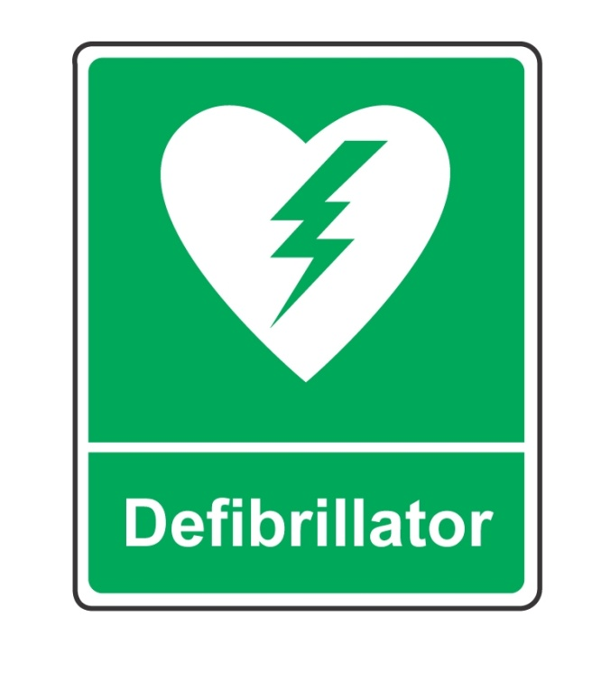
UK STANDARDISED AED SIGN

MAINTENANCE
Users of an AED are not expected to carry out any maintenance tasks other than replacing the batteries, electrode pads and other consumable items (razor, gloves, scissors etc.)In all cases the manufacturer’s instructions should be followed. All currently available AEDs perform regular self-checks (as mentioned earlier). In most cases if there is a problem a warning sign or light is visible on the front of the machine. Those owning an AED should have a process in place for it to be checked regularly (ideally daily) for such a warning, and for appropriate action to be taken when necessary. If this task is delegated to individuals, allowance must be made for absence due to sickness, holidays, etc. Most manufacturers provide a replacement while the AED is removed for servicing, so the arrangements for this should be clarified and agreed during the process of buying the machine.
LEGAL ISSUES
In some countries, and in most states in the USA “Good Samaritan” legislation protects those who go to the help of others. No such legislation exists in the UK, so for many people the first major concern is the legal situation of those who attempt to resuscitate someone. The short answer is that it is very unlikely that a potential rescuer could be sued. In English law, for someone to be held liable it would have to be shown that the intervention had left the victim in a worse situation than if there had been no intervention at all, so it is very unlikely that this would be the case. No case brought against someone who tried to provide first aid has been successful in the UK, where the courts have tended to look favourably on those who try to help others. This subject has been considered in detail, and detailed legal advice is offered on the Resuscitation Council (UK) website: http://www.resus.org.uk/pages/legal.pdf
The second concern is whether someone might be sued for failing to have an AED available when someone has sustained a cardiac arrest – there have been high-profile cases in other countries where this has happened. Legal advice on this subject is also available on page 16 of the document mentioned above.

References:
Resuscitation Council (UK) www.resus.org.uk enquiries@resus.org.uk British Heart Foundation www.bhf.org.uk

